# Initial Setup

Upon opening the form you will need to enter all the information on the main screen.

## Crewrest Options

* Enter the default start time for crewrest. The time it is set to will be the time entered when using quick *Add Crewrest* buttons.
* Meal Alibi is what will be put on the justification sheet for AF Finance.
* Missed Meal will be the default meal missed for crewrest. If you typically fly early morning you would select *Dinner - Government*.

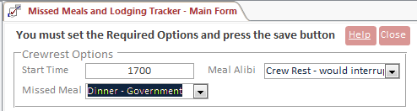

## Aircrew Options

* Meal Alibi will set the Justification text. This is typically *Flying*.  
  

## Required Options

* Default Location should equal the place you are staying for government/open lodging.
* Meal Category will typically be Government if you are TDY.
* Beginning date is the date of departure from home station.
* Ending date is the last date on your orders. This can be adjusted to be more or less days later.

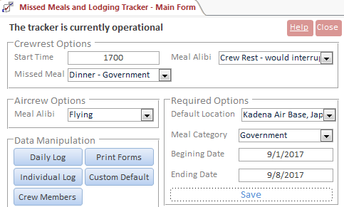

When all the data is entered press *Save* and the test at the top will say it is operational.

# Add Crewmember

On the main form click on *Crew Members*. This will open a new form that should have no data.

## Personal Details

Enter in the member’s name. It is advised to set the member’s Social to *123456789* until you are ready to print. The database becomes PII when a social is entered.

## Official Information

Enter the member’s Order’s ID. This is found on the orders and is typically TE-xxxx.

Enter the order’s start and end dates.

Select the member’s Organization.

## Crew Settings

Checking *Add to Default Crew* will auto-add the member to each day. If the member is not part of the flight crew then it will keep from adding them.

After that press the appropriate save button. You will then see the member on the left menu.

# Remove Crew Member

On the main form click on *Crew Members*.

On the left side of the form there should be a list of names if you entered data. Click on the member you want to remove.

Click the red *Remove Member* button. Click OK on the warning message.

# Modify Squadrons/Organizations

On the main form click on *Crew Members*.

Click on the blue *Organizations* text under *Official Information* for any member.

Modify the data as needed and then close the form.

# Managing Missed Meals/Lodging

## Controls and Interface

These buttons will navigate through the tracker. The far left and right buttons will move to the beginning and the end of the saved data.



Pressing the crew rest button will add the default crewmembers, default crewrest time, meal, reason, and location.

Flight button will do the same as *Crewrest* but instead set the date as a flight.

Add crew will only add the default members. Use this for special cases.

Custom Default will set the date to custom default. You need to set what the default values will be. It will not add members. To learn how to do this see the Custom Defaults chapter.



Clear Crew will remove all crew members from the selected date.

Clear All will remove all data for that date, including crewmembers and meal data.



## Crew-wide Management

This section will describe how to manage a missed event for the entire crew.

On the main form click on the *Daily Log* button. This form will appear.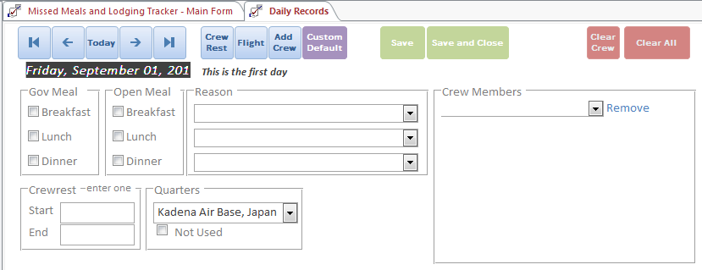

This form is pretty self-explanatory. Essentially just make the form look like what you did. If you missed a meal select that meal, set the reason. If you did crewrest you can choose to enter either the start or the end time or choose to press the crew rest button on the top.

## Individual Management

This section will describe how to manage a missed event for one crew member.

On the main form click on the *Individual Log* button. This form will appear.

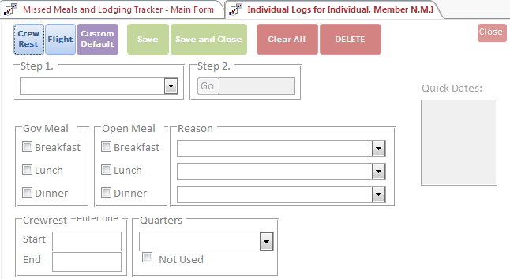

First you have to select the member from the Step 1 section followed by the date in Step 2.

## Custom Defaults

Custom Defaults is where to set custom settings for events like mission planning. Select all appropriate settings and then hit save.

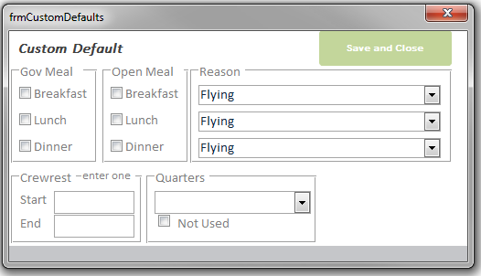

# Printing Missed Meals Forms

To print the forms you need to click the *Print Forms* button on the main form. Currently this is the same as *Crew Members* but this will change in a future version.

* AF IMT 2282 is the form that your AC will need to sign if you are aircrew, or another supervisor.
* Justification is the required document explaining why the date has events claimed. This is required per the instructions on the back of the AF IMT 2282 form.

To print each form you need to click each button and press *CTRL + P*.

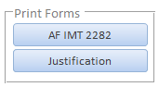

# Example Screenshots

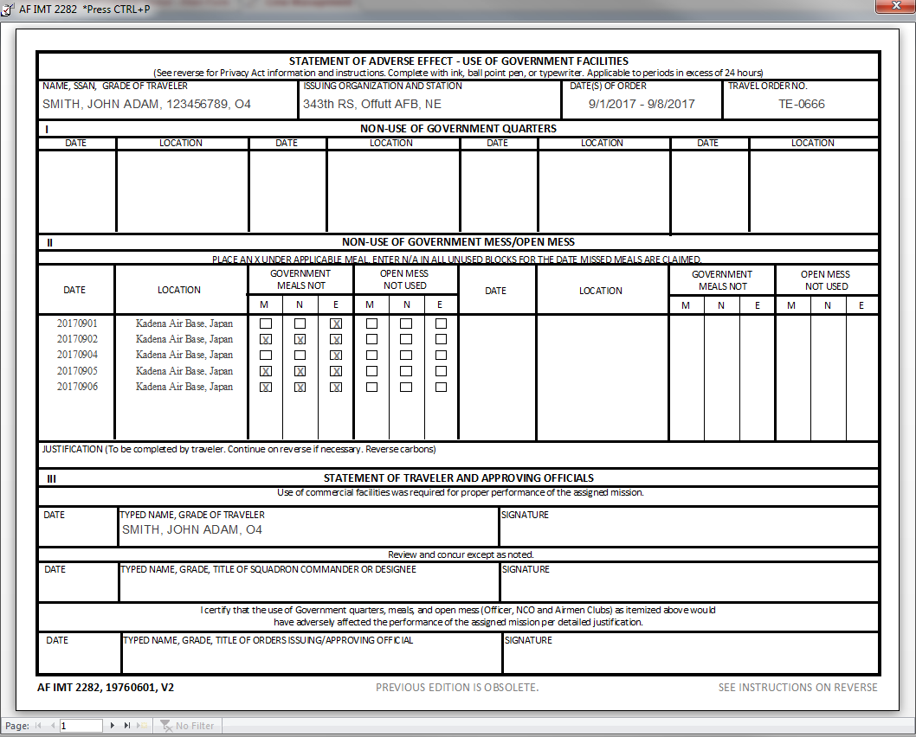

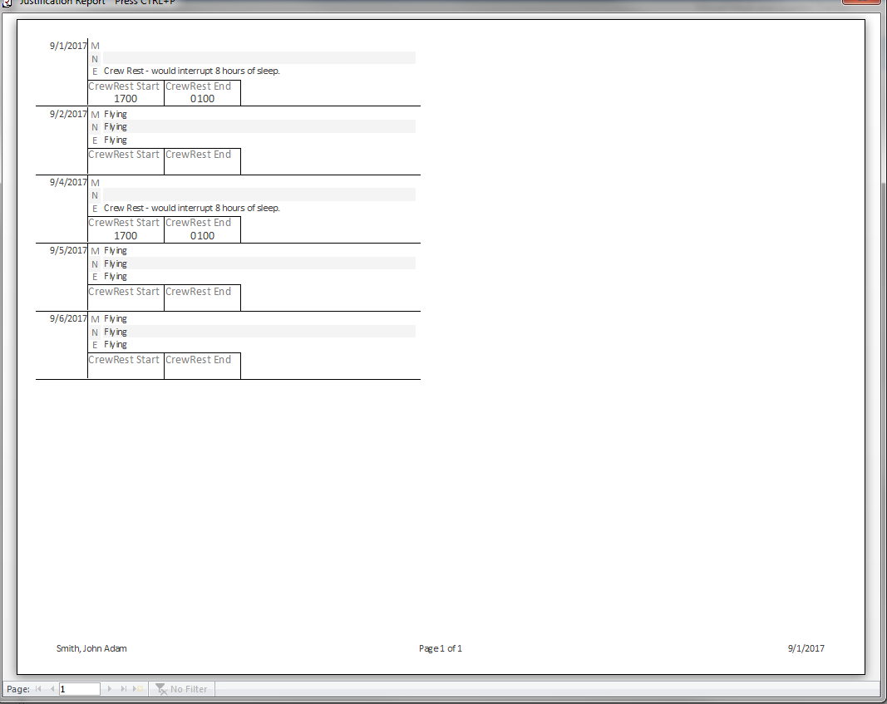

# DTS Information

When entering data into DTS just remember that you check the opposite checkboxes as on the forms. On DTS you are checking ones you had verses here you check the ones you missed.

## Examples

These examples are for a TDY to Kadena AB. CAO 8 July 2017.

### Missed Dinner / Crew rest at night

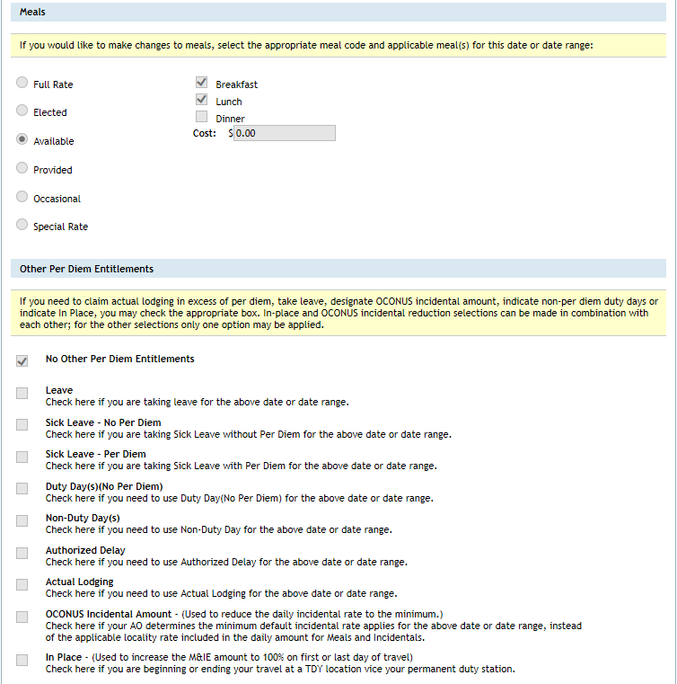

### Missed all Meals/ Flight

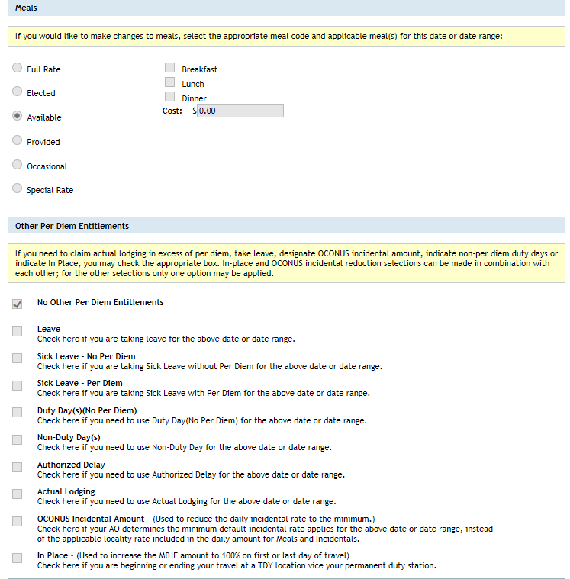

### Had all meals/ did not fly, work, crew rest

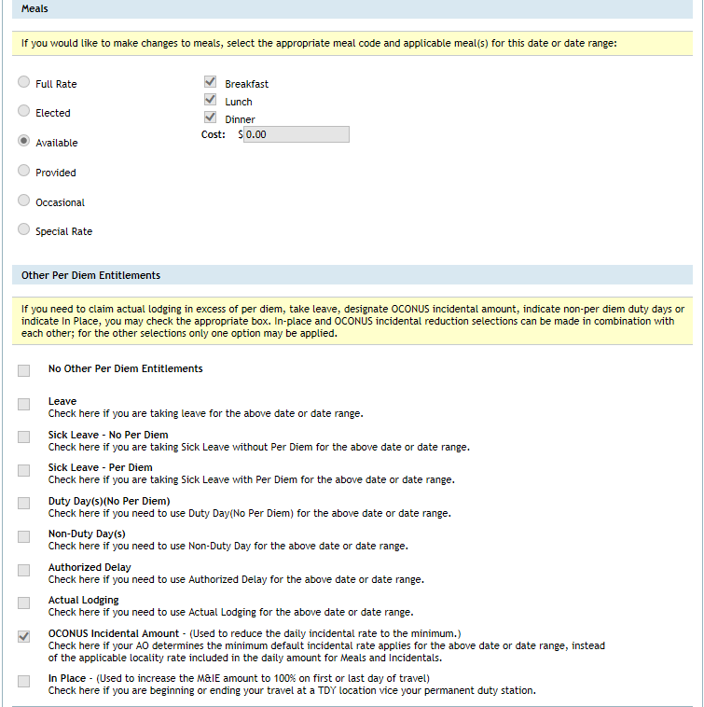

### Uploaded Documents

Make sure that you upload the missed meals PDFs that are signed by your applicable supervisor or commander, and IPR.

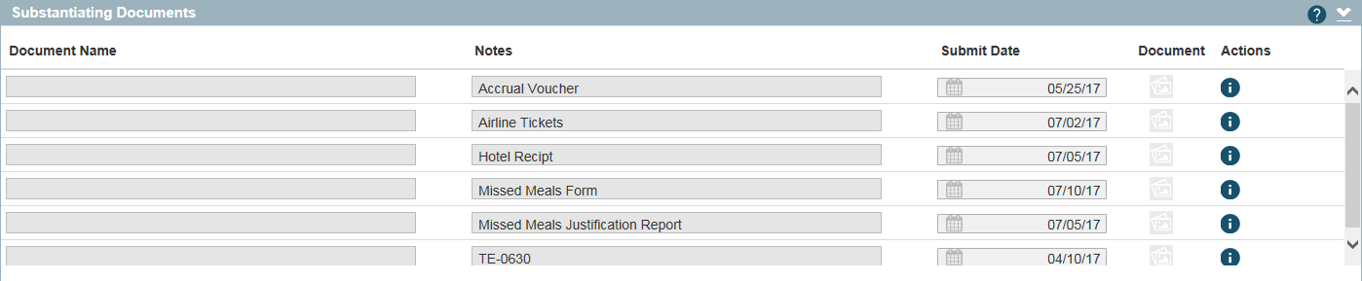

### Air Force Finance

You will need to take the signed AF IMT 2282 to finance along with the justification as well.